TITLE OF THE PROJECT

Pre-Defined Email Generator

SYNOPSIS REPORT REVIEW - III

By-

Animesh Srivastava (RA1611003030250)

Udeshya Mittal (RA1611003030249)

Submitted to the Department of Computer Science and Engineering

in partial fulfillment of the requirements

for the degree of

Bachelor of Technology in

Computer Science and Engineering



SRM Institute of Science and Technology

April, 2018

**TABLE OF CONTENTS**

proposed model overview 3

model design (flow chart) 5

module homepage 6

suggestion 7

suggestion screenshot 9

feedback 10

feedback screenshot 12

complaint 13

complaint screenshot 15

software used 16

html 17

Dreamweaver 18

JavaScript 19

css 20

reference 21

PROPOSED MODEL

Overview:

Our aim is to made a predefined email generator. As we all know that online complaint have a much greater impact and they are basically in tend. As usually when we have some complaint or suggestion we are not able to contact customer care through call which is basically a major problem in India.

First of all we have to find a correct customer care number and when we have find a correct customer care number then first of all customer has to choose his problem from a list of options.

After choosing his problem from that list then he is able to contact to a customer care executive. To save our user precious time our project is predefined email generator.

In this we will provide you pre-generated email regarding your problems and you have to just edit your particulars like your name, phone number and then you can send that email.

In our project user will get variety of options regarding his/her complaint and emails according to that complaint and then user can send that email.

In our project user will not only get emails for their complaints but also for their suggestion and feedback.

The emails which we provide will be user friendly as the user as the person with minimum knowledge of computer can easily use our email.

The emails which we provide will have zero grammatical mistakes. Our website will also have email editing flexibility according to user. If user thinks that he/she has to edit something in our email as our email is not upto his requirements according to him in that case the user can edit email and change it according to him and then send it.

If you don’t find any option in our website according to your complaint in that case you can also give us suggestion about that and we will provide you with the email.

As you know you can edit email according to your needs in that case if you thinks that we should keep that change in that email then you can also suggest us about that and we will work on it.

Feedback option will also be provided in our email that If you want to give feedback to any service provider in that case you can give them feedback about any of their services.

We will also provide you with the exact email address of different companies or service providers like Indian railways, Airways, Telecommunication, School/college etc.

As nowadays email complaints will get instant response in comparison to other modes. So to encourage this we are coming with the project of pre-defined email.

In our website we will provide you with four different webpages in first webpage we will provide you that which option you want to choose.

In second webpage we will provide you with slides of different options regarding your complaint, suggestion or feedback.

When you choose a particular option of exactly what you need. Then you will get an email for that and you can edit your particulars in that and we will also provide you with email editing option to change your email according to your need and then in last webpage you can send that email.

Model Design Flow Chart-

WEBSITE

SUGGESTION

FEEDBACK

COMPLAINT

RAILWAYS

HOSPITAL

TELECOM

AIRLINES

SCHOOL

COLLEGE

LEAVE FOR APPLICATION

SANITARY

CONDITION

NETWORK

PROBLEM

REFUND

Module:

HomePage:

The homepage of our predefined email generator include the desing format as a banner which include a background image of a ocean (can be also changed according to need) in which SRM Email Services is Written , also written learn leap and lead in small .

Also name of group members is also added under the main heading banner .

In the above banner we have added a three buttons as mentioned below –

* Suggestion
* Feedback
* Complaint

Also not only for other companies , network companies etc are added but also added for suggestion , complaint and feedback option for our own website in which you can give your view as of suggestion , complaint or feedback regarding to the website.

Also under the lower banner we have added a About the website section in which one can view the purpose of the website and additional data.

We also have added the animation in the main banner section . The Homepage is made light and attractive so as to load faster even on 2g networks.

Also the Homepage has a well defined layout so as to fit in the mobile screen too and desktop.

Suggestion-

In our website we will give you option to give your feedback for any service you used. For that you have to follow following steps.

First of all when you visit our website we will give you three options to be select from. The three options will be suggestion complaint feedback

In our website you can give Suggestion for several things some of the following are below-

* School
* Railways
* Colleges
* Offices
* Hospitals
* Hotels

And also much more. In the suboptions of all this our website will include the following options-

* Sanitary Condition
* Refund
* Network Problems
* Food hygene

Let’s take the case of suggestion. When you click on suggestion on our website then you will be directed to another webpage and there you can select from the list of options that to whom you want to give feedback.

Then you can easily select from the list as there are mostly all the options present that are used in day to day life and you will definitely get the option of your need. That suggestion page slide show will be set to two seconds time.

In every two seconds next slide will be displayed. When you choose option of your choice at that time you will be then directed to a new webpage. In that webpage you will get the suggestion that for which service you want to suggest something.

When you have selected your problem for which you want to give suggestion then you will get a pre-defined email for that. Then you can edit your particulars in that email and send that.

If you think that our email is not sufficient to explain what you want in that case we will also provide you with email editing option so that you can edit email according to your need and then send it.



Screenshot of Suggestion Webpage:

Feedback:

Our website not only have complaint and suggestion option but also have options for Feedback which is as important as complaint and suggestion.

Like we give feedbackor review about railways etc. In our website you can give feedback for several things some of the following are below-

* School
* Railways
* Colleges
* Offices
* Hospitals
* Hotels

And also much more. In the suboptions of all this our website will include the following options-

* Sanitary Condition
* Refund
* Network Problems
* Food hygene

Like for example one clicks School or colleges then he/she can add feedback about the sanitary condition , Food Hygiene also like if some clicks Railways we will also have mutual options which include Sanitary condition , Food Hygiene as in School / Colleges also have additional options like in railways beside Food hygiene and sanitary condition we have refund feedback etc.

For accessing First when we click on homepage feedback we will redirect to next webpage in which a slider which the options as mentioned below be there the slider automatically slides in every next 2 seconds also manul buttons are added to it .

After clicking one option you will be redirected to nexr webpage where again a slider will occur in where the suboptions will be present.

After clicking on the suboptions the mails regarding the suboptions feedback will occur and the one can edit it according to there flexiblty and add their name etc .

As the mails will be present you can send it by clicking on the button which will redirect you to gmail section where also you can edit it attach something and send it to the one you need which no grammatical mistakes and with correct format .

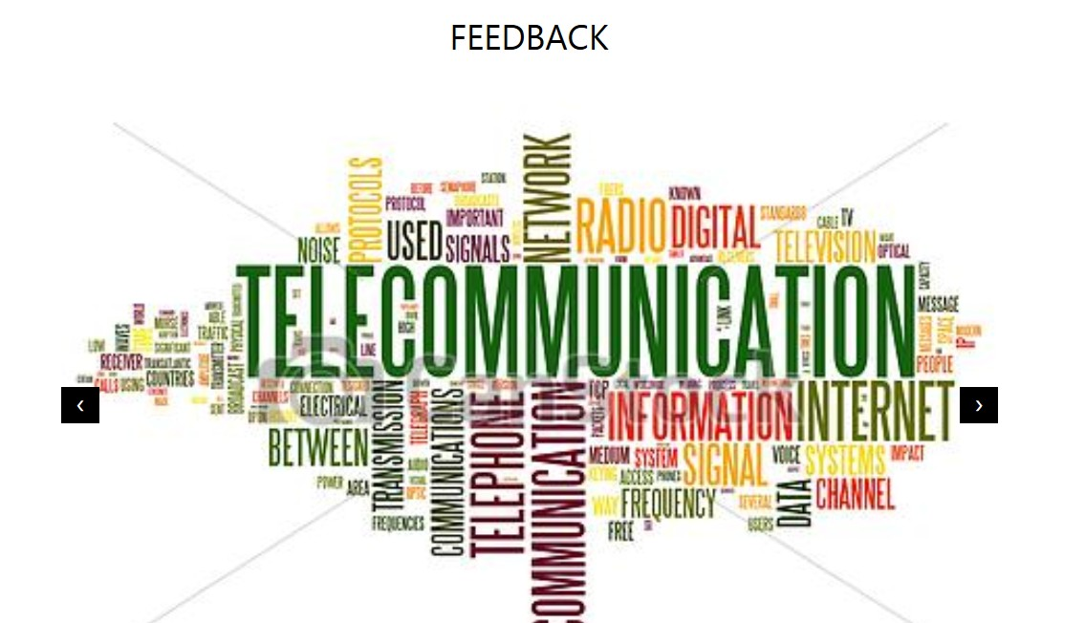

Screenshot of Feedback Webpage:

Complaint:

In our website you also find pre-defined email for complaint for any service you have used. For that you have to follow following steps.

First of all when you visit our website we will give you three options to be select from. The three options will be suggestion, complaint, Feedback .

.In our website you can give complaint for several things some of the following are below-

* School
* Railways
* Colleges
* Offices
* Hospitals
* Hotels

And also much more. In the sub options of all this our website will include the following options-

* Sanitary Condition
* Refund
* Network Problems
* Food hygiene

Let’s take the case of complaint. When you click on suggestion on our website then you will be directed to another webpage and there you can select from the list of options that to whom you want to give complaint.

Then you can easily select from the list as there are mostly all the options present that are used in day to day life and you will definitely get the option of your need. That complaint page slide show will be set to two seconds time.

In every two seconds next slide will be displayed. When you choose option of your choice at that time you will be then directed to a new webpage. In that webpage you will get the complaint that for which service you want to suggest something.

When you have selected your problem for which you want to give suggestion then you will get a pre-defined email for that. Then you can edit your particulars in that email and send that.

If you think that our email is not sufficient to explain what you want in that case we will also provide you with email editing option so that you can edit email according to your need and then send it.

Screenshot of Complaint Webpage:

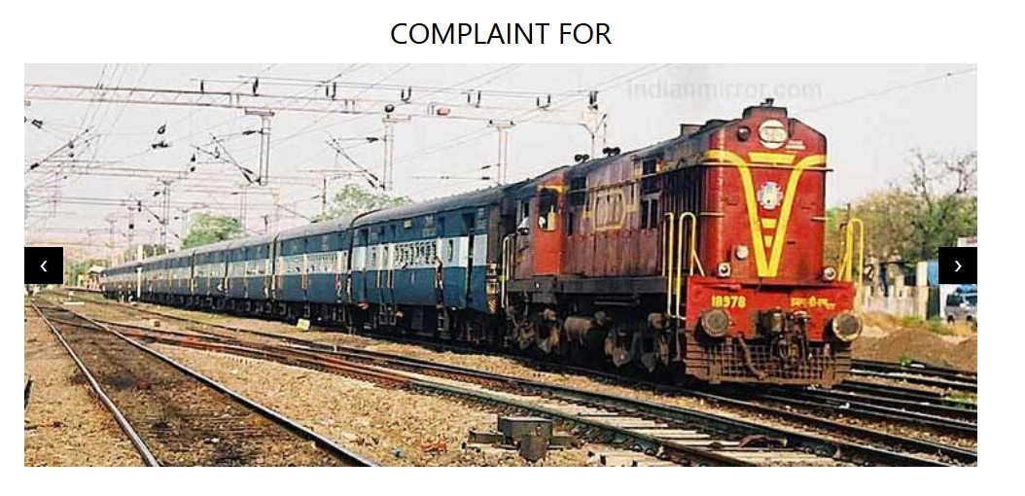

Software and Programming Language Used-

The following are the Software and Programming language used-

* HTML
* CSS
* Javascript
* Dreamweaver

HTML

HTML is a computer language devised to allow website creation. These websites can then be viewed by anyone else connected to the Internet. It is relatively **easy to learn**, with the basics being accessible to most people in one sitting; and quite **powerful** in what it allows you to create. It is constantly undergoing revision and evolution to meet the demands and requirements of the growing Internet audience under the direction of the [**» W3C**](http://www.w3.org/), the organization charged with designing and maintaining the language.

How does it work?

HTML consists of a series of short **codes** typed into a text-file by the site author — these are the tags. The text is then **saved as a html file**, and **viewed through a**[**browser**](http://www.yourhtmlsource.com/starthere/glossary.html#browser), like *Internet Explorer* or *Netscape Navigator*. This browser reads the file and translates the text into a visible form, hopefully rendering the page as the author had intended. Writing your own HTML entails using tags correctly to create your vision. You can use anything from a rudimentary text-editor to a powerful graphical editor to create HTML pages.

## **Features of HTML**

1) It is a very easy and simple language. It can be easily understood and modified.

2) It is very easy to make effective presentation with HTML because it has a lot of *formatting tags*.

3) It is a markup language so it provides a flexible way to design web pages along with the text.

4) It facilitates programmers to add link on the web pages (by *html anchor tag*) , so it enhances the interest of browsing of the user.

5) It is platform-independent because it can be displayed on any platform like Windows, Linux and Macintosh etc.

6) It facilitates the programmer to add Graphics, Videos, and Sound to the web pages which makes it more attractive and interactive.

DREAMWEAVER

Adobe Dreamweaver is a proprietary web development tool from Adobe Systems. It was created by Macromedia in 1997 and developed by them until Macromedia was acquired by Adobe Systems in 2005.

Adobe Dreamweaver is available for macOS and for Windows.

Following Adobe's acquisition of the Macromedia product suite, releases of Dreamweaver subsequent to version 8.0 have been more compliant with W3C standards. Recent versions have improved support for Web technologies such as CSS, JavaScript, and various server-side scripting languages and frameworks including ASP (ASP JavaScript, ASP VBScript, ASP.NET C#, ASP.NET VB), ColdFusion, Scriptlet, and PHP.

Adobe Dreamweaver CC is a web design and development application that combines a visual design surface known as Live View and a code editor with standard features such as syntax highlighting, code completion, and code collapsing as well as more sophisticated features such as real-time syntax checking and code introspection for generating code hints to assist the user in writing code. Combined with an array of site management tools, Dreamweaver lets its users design, code and manage websites, as well as mobile content. Dreamweaver is an Integrated Development Environment (IDE) tool. You can live preview of changes for the frontend. Dreamweaver is positioned as a versatile web design and development tool that enables visualization of web content while coding.

Dreamweaver, like other HTML editors, edits files locally then uploads them to the remote web server using FTP, SFTP, or WebDAV. Dreamweaver CS4 now supports the Subversion (SVN) version control system.

## JavaScript

JavaScript is a cross-platform, object-oriented scripting language used to make webpages interactive (e.x. having complex animations, clickable buttons, popup menus, etc.).  There are also more advanced server side versions of JavaScript such as Node. Js which allow you to add more functionality to a website than simply downloading files (such as real-time collaboration between multiple computers). Inside a host environment (for example, a web browser), JavaScript can be connected to the objects of its environment to provide programmatic control over them.

JavaScript contains a standard library of objects, such as Array, Date, and Math, and a core set of language elements such as operators, control structures, and statements. Core JavaScript can be extended for a variety of purposes by supplementing it with additional objects; for example:

* Client-side JavaScript extends the core language by supplying objects to control a browser and it’s Document Object Model (DOM). For example, client-side extensions allow an application to place elements on an HTML form and respond to user events such as mouse clicks, form input, and page navigation.
* Server-side JavaScript extends the core language by supplying objects relevant to running JavaScript on a server. For example, server-side extensions allow an application to communicate with a database, provide continuity of information from one invocation to another of the application, or perform file manipulations on a server.

This means that in the browser, JavaScript can change the way the webpage (DOM) looks. And, likewise, Node.js JavaScript on the server can respond to custom requests from code written in the browser.

CSS

CSS is a language that describes the style of an HTML document.CSS describes how HTML elements should be displayed.

CSS is designed primarily to enable the separation of presentation and content, including aspects such as the [layout](https://en.wikipedia.org/wiki/Page_layout), colors, and [fonts](https://en.wikipedia.org/wiki/Typeface).[[3]](https://en.wikipedia.org/wiki/Cascading_Style_Sheets#cite_note-3) This separation can improve content [accessibility](https://en.wikipedia.org/wiki/Accessibility), provide more flexibility and control in the specification of presentation characteristics, enable multiple HTML pages to share formatting by specifying the relevant CSS in a separate .css file, and reduce complexity and repetition in the structural content.

Separation of formatting and content makes it possible to present the same markup page in different styles for different rendering methods, such as on-screen, in print, by voice (via speech-based browser or screen reader), and on [Braille-based](https://en.wikipedia.org/wiki/Braille_display) tactile devices. It can also display the web page differently depending on the screen size or viewing device. Readers can also specify a different style sheet, such as a CSS file stored on their own computer, to override the one the author specified.

Changes to the graphic design of a document (or hundreds of documents) can be applied quickly and easily, by editing a few lines in the CSS file they use, rather than by changing markup in the documents.

The CSS specification describes a priority scheme to determine which style rules apply if more than one rule matches against a particular element. In this so-called *cascade*, priorities (or *weights*) are calculated and assigned to rules, so that the results are predictable.

REFRENCES:

* https://en.wikipedia.org/wiki/JavaScript
* https://www.tutorialspoint.com
* https://www.w3schools.com/html/
* https://www.youtube.com/watch?v=k3dJKtQmyd0
* https://www.youtube.com/watch?v=ctI1XUjueaE
* https://www.youtube.com/watch?v=nKf8OVyXvrg